Rhino Resurfacing Machine

RLP800

Operator’s Manual

For your personal safety, READ and UNDERSTAND before using. SAVE THESE INSTRUCTIONS FOR FUTURE REFERENCE.

SPECIFICATIONS

Model | Specifications
Battery (APP16L) | 12V 16Ah
Engine Briggs and Stratton 810CC | Vaper propane only
Tank (PS5306TC) | 3.2 Gallon
Disc Diameter | 7’’
Disc Speed (RPM) | 200-900
Machine Width | 20’’
Weight | 800lbs / 363kg

GENERAL SAFETY RULES
WARNING! Read and understand all instructions. Failure to follow all instructions listed below, may result in electric shock, fire and/or serious personal injury. SAVE THESE INSTRUCTIONS.

Work Area
- Keep your work area clean and well lit.
Cluttered floors and dark areas invite accidents.
- DO NOT operate equipment in explosive atmospheres, such as in the presence of flammable liquids, gases or dust. Grinding can create sparks which may ignite the dust or fumes.
- Keep bystanders, children, and visitors away while operating equip- ment. Distractions can cause you to lose control.

Electrical Safety
- DO NOT use any other types of parallel battery.
- DO NOT bypass the battery or any of the safety sensors.

Personal Safety
- Stay alert, watch what you are doing and use common sense when operating equipment. Do not use equipment while tired or under the influence of drugs, alcohol, or medication. A moment of inattention while operating equipment may result in serious personal injury.
- Do not overreach. Keep proper footing and balance at all times. Proper footing and balance enables better control of the equipment in unexpected situations.
- Use safety equipment. Always wear eye protection. Dust mask, non-skid safety shoes, hard hat, or hearing protection must be used for appropriate conditions. Ordinary reading glasses or sunglasses are NOT eye protection.
- DO NOT Turn on equipment while the machine is tilted back. Any tooling fastened to the machine can eject and become a lethal projectile.

Equipment Use and Care
- The equipment is designed to remove excess surface material. To prevent damage to the equipment and/or serious personal injury, beware of protruding objects or other debris embedded in the surface being finished.
- Turn it off the engine before making any adjustments, changing accessories, or storing equip-

ment. Such preventive safety measures reduce the risk of starting the equip- ment accidentally.
- Maintain equipment with care. Keep tools and accessories in good condition. Properly maintain tools. Sharp cutting edges are less likely to fail and are easier to control.
- Check for binding of moving parts, breakage of parts, and any other condi- tion that may affect the equipment's operation. If damaged, have equipment serviced before using. Many accidents are caused by poorly maintained equip- ment.
- Use only tools and accessories that are recommended by the manufacturer for your equipment. Tools and accessories that may be suitable for style of equipment, may become hazardous when used on another style of equip- ment.

SERVICE
- DO NOT modify the machine. Modifi- cations will void warranty and could result in unsafe operation of equipment.
- Equipment repairs should be performed only by qualified repair personnel. Service or maintenance performed by unqualified personnel could result in a risk of injury.
- When servicing equipment, use only identical replacement parts. Use of unauthorized parts may create a risk or injury.

SPECIFIC SAFETY RULES
DO NOT let comfort or familiarity with product (gained from repeated use) replace strict adherence to equipment safety rules. If you use this equipment unsafely or incorrectly, you can suffer serious personal injury.
- Tools and accessories must be rated for at least the speed stated on the equipment serial plate. Tools and other accessories running overrated speed can fly apart and cause injury.

- Adequate ventilation of your work area is very important when using equipment. Use a dust mask or appro- priate respirator.
- Due to the dusty nature, during use of this equipment, be sure to clean equip- ment often to remove dust accumula- tions. Carefully blow the dust out of the engine and check the air filter under the shroud cap. If necessary, replace the air filter.
- Always check if the floating dust skirt is in good condition and touching the floor before operation.
- Check the tools and accessories carefully for cracks or damage before operation. Replace cracked or damaged tools and or accessories immediately.
- Hold the equipment firmly with both hands during operation.
- Do not leave the equipment running unattended.
- Do not touch the tools immediately after stopping operation; they may be extremely hot and could burn your skin.

WARNING: Misuse or failure to follow the safety rules stated in this instruction manual may cause serious personal injury. SAVE THESE INSTRUCTIONS.

Machine Operation:
The engine runs with propane vaper only designed to allow the user to operate the equipment with lower and higher RPM (3600 MAX).

LCD DISPLAY – Shows RPM of the engine and running hours.
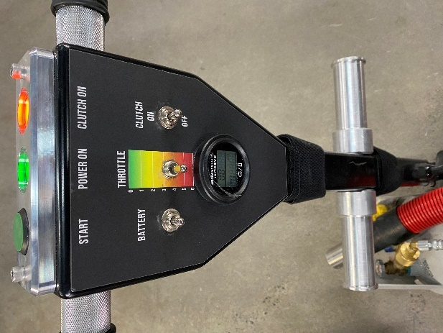

Starting the equipment:
Once a day if the machine is in use Check the oil level and check for any leaks, either oil or propane.
1. Turn on propane
• Make sure tanks are not overfilled
• Don’t tilt more than 15 degrees so as to not suck up liquid.
• As tank level goes down you can increase to 45 degrees.

2. Turn on battery switch.

3. Make sure clutch switch is off (if its on the orange light will come on) Also make sure that you have the correct tooling on the tool plates and that the drive pins are properly seated into the grommets. A spray of WD40 on the grommets helps the pins to go in particularly on new grommets.

4. Depress green start button until engine starts.
• Let engine run for 5 minutes or so to warm up.

5. Increase engine RPM by holding throttle switch down to increase to 2000-2200 RPM.

6. Engage Clutch and Apply downward pressure on the handle to alleviate some pressure of the tools. Once the equipment gets started, gently release the downward pressure, and start grinding.

7. To stop grinding -decrease RPM and then disengage clutch by turning off toggle switch (the orange light will turn off)

8. Turn off battery switch to stop engine.

9. If machine is not being used for more than 15 minutes or longer then turn off propane at the tank.
NOTE:
The equipment is designed to rotate the tooling in one direction ONLY. The RED plates spin counterclockwise while the black plates spin clockwise. The orientation of tooling is important for directional tooling, such as PCD’s.
The heads speed is controlled by throttling the engine. The RPM of the engine will be showed in the tachometer.
Note: Do not run the machine with the propane tank over floated. Do not run the machine tilted back or with the propane tank leaning more 15 ° vertically. Do not store the machine leaning back, not following the manufacture recommendations could cause damages to the equipment or injuries.

never exceed the maximum speed of the tooling being used! Doing so could cause tooling to eject from the tool plate holder or cause irreparable damage to the surface being finished.

DO NOT TILT OR LIFT THE EQUIPMENT OFF THE GROUND WHILE STARTING OR RUNING! Doing so can cause the tools to release from the equipment and cause damage to the surface being finished and harm to the user!

Stopping the equipment:
To stop the equipment. We advise that closing the propane tank valve and blinding the line is the proper way for stopping the machine, although in emergency stop or a fast tool change over it is possible to stop the engine by using the battery kill switch. In both cases the clutch MUST be disengaged first.

Changing tools and accessories:
Always turn off the engine and wait for a full stop when performing any operations to the bottom of the machine!
To change tool segments on the tooling plate, use a 13mm wrench or socket and/or a battery powered impact driver. Remove 8mm bolt and lock washer, inspect threads if still in good condition they may be used to mount new segments. Always start screws by hand first to avoid cross threading. Be cautious to not over-tighten.
When removing and inserting tool plates or adapter plates, be sure to inspect rubber grommets for signs for wear and replace any damaged grommets.
Using grommets that are damaged or missing can cause unexpected equipment operation and increase the chance of tool plate / adapter plate ejection or violent vibration leading to loss of control of equipment and, damage to the tool plates and drive heads.

Handle adjustment:
To adjust the handle, pull either hand latch or depress foot latch on the handle and move handle up or down to the desired position. Make sure that latch teeth engage completely

when the desired position is achieved.

Failure to check for positive engagement in between the could result in damage to the equipment or injury to the user as the handle could release unexpectedly when the machine is being operated or tilted back!

Maintenance:
General:
- Kill the battery switch before and close the propane while performing any maintenance, cleaning, or repairs to your equipment!
- When the equipment is not in use, make sure that the adapter plate assemblies have something attached to them to protect the Velcro. Resting the machine directly on unprotected Velcro will crush the fastening material causing the Velcro to become unusable.

Daily:
- Wipe down the equipment after every job.
- Gently remove dirt and debris from the velcro hook using vacuum. This will ensure maximum adhesion.
- Check that the handle bolts are tight.
- Vacuum or wipe underside of machine.
- Inspect exposed electric connection ends for signs of carbon deposits or arcing. Tighten loose screws
- Check for any Oil or propane leak.
- Check the air filter.
- Check all fasteners and tighten if necessary.

Monthly:
- Inspect handle wires for damage.
-Clean or replace air filter.pressure compressed air (30psi or less).
- Cleaning the engine prevents fan
with compressed air (30psi or less).
Blow off engine fan with compressed air (30psi or less).
- Remove tool plate holders and wipe down seal plates with a damp cloth. Do not use any sharp object or abrasive pad to clean the seal plates.
- Using a soft scrub pad, remove any excess dirt build up from the bottom plate and back side of pad drivers.
- Inspect tool plate driver grommets for signs of wear. Replace grommets that show signs of extensive wear.

Yearly or after 100 hours of use.

- Change the oil and the oil filter. SAE 5W30 (it takes 2.1L with a new filter) Check for possible overflow. Oil Filter P# B&S695396.
- Change the air filter P# B&S 798897
- Clean and lubricate wheels.
- Clean and lubricate handle latch mechanism.

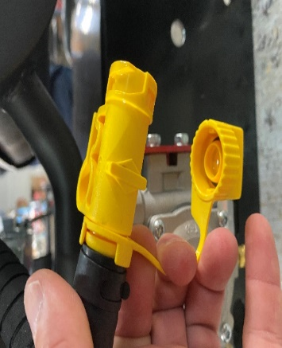
(Oil draining valve)

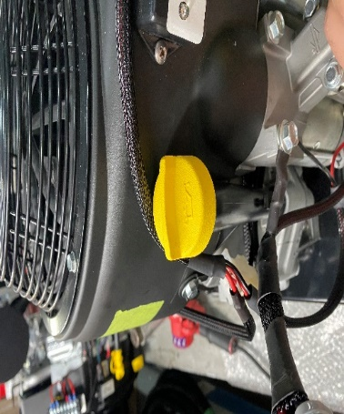
(Oil cap and deep stick)

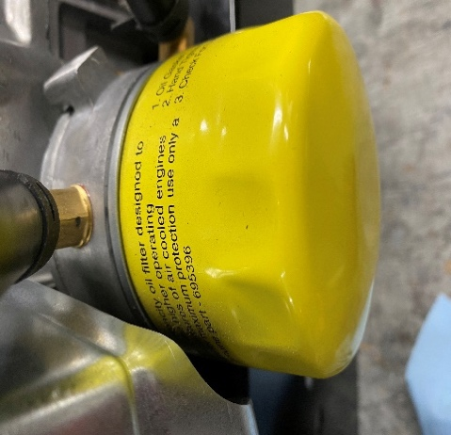
(Oil filter)

LIMITED EQUIPMENT WARRANTY OF SALE
NewGrind Inc. warrants that each new unit manufactured by New Grind Inc. to be free from defects in material and workmanship in normal use and service for a period of three years from date of shipment to the original retail or equipment rental center owner. Accessories or equipment furnished and installed on the product by New Grind Inc. but manufactured by others, including, but not limited to engines, motors, electrical components, transmissions etc., shall carry the accessory manufacturers own warranty. New Grind Inc. will, at its option, repair or replace, at the NewGrind Inc. factory or at a point designated by NewGrind Inc. any part which shall appear to the satisfaction of NewGrind Inc. inspection to have been defective in material or workmanship. New Grind Inc. reserves the right to modify, alter and improve any part or parts without incurring any obligation to replace any part or parts previously sold without such modified, altered or improved part or parts. This warranty is in lieu of and excludes all other warranties, expressed, implied, statutory, or otherwise created under applicable law including, but not limited to the warranty of merchantability and the warranty of fitness for a particular purpose in no event shall seller or the manufacturer of the product be liable for special, incidental, or

consequential damages, including loss of profits, whether or not caused by or result- ing from the negligence of seller and/or the manufacturer of the product unless specifically provided herein. In addition, this warranty shall not apply to any products or portions there of which have been subjected to abuse, misuse, improper installation, maintenance, or operation, electrical failure or abnormal conditions and to products which have been tampered with, altered, modified, repaired, reworked by anyone not approved by seller or used in any manner inconsistent with the provisions of the above or any instructions or specifications provided with or for the product

FORCE MAJEURE
Seller’s obligation hereunder are subject to, and Seller shall not be held responsible for, any delay or failure to make delivery of all or any part of the product due to labor difficulties, fires, casualties, accidents, acts of the elements, acts of God, transportation difficulties, delays by a common carrier, inability to obtain product, materials or components or qualified labor sufficient to timely perform part of or all of the obligations contained in these terms and conditions, governmental regulations or actions, strikes, damage to or destruction in whole or part of manufacturing plant, riots, terrorist attacks or incidents, civil commotions, warlike conditions, flood , tidal waves, typhoon, hurricane, earthquake, lightning, explosion or any other causes, contingencies or circum- stances within CANADA not subject to the Seller’s control which prevent or hinder the manufacture or delivery of the products or make the fulfillment of these terms and conditions impracticable. In the event of the occurrence of any of the foregoing, at the option of Seller, Seller shall be excused from the performance under these Terms and Conditions, or the performance of the Seller shall be correspondingly extended. This document sets forth the terms and conditions pursuant to which the purchaser (“Purchaser”) will purchase and New Grind Inc. (“Seller”) will sell the products, accessories, attach-
ments (collectively the products “) ordered by the Purchaser. These terms and condi- tions shall govern and apply to the sale of Seller’s products to Purchaser, regardless of any terms and conditions appearing on any purchase order or other forms submit- ted by Purchaser to Seller, or the inconsistency of any terms therein and herein.

LIABILITY LIMITATIONS
The remedies of the user set forth under provisions of warranty outlined above are the exclusive and total liability of New Grind Inc. with the respect to their sale or the equipment and service furnished hereunder, in connection with the performance or
breach thereof, or from the sale, delivery, installation, repair or technical direction covered by or furnished under the sale, whether based on contract, warranty, negligence, indemnity, strict liability, or otherwise shall not exceed the purchase price of the unit of equipment upon which such liability is based.
New Grind Inc. will not in any event be liable to the user, any successors in interest or any beneficiary or assignee relating to this sale for any consequential, incidental, indirect, special or punitive damages arising out of this sale or any breach thereof, or any defects on, or failure of, or malfunction of the equipment under this sale based upon loss of use, lost profits or revenue, interest, lost goodwill, work stoppage, impairment of other goods, loss by reason of shutdown or non- operation, increased expenses of operation of the equipment, cost of purchase or replacement power of claims of users or customers of the user for service interruption whether or not such loss or damage is
based on contract, warranty, negligence, indemnity, strict liability, or otherwise.
New Grind Inc. reserves the right to modify, alter and improve any part or parts without incurring any obligation to replace any part or parts previously sold without such modified, altered or improved part or parts.
No person is authorized to give any other warranty or to assume any additional

obligation on New Grind Inc.'s behalf unless made in writing and signed by an officer of New Grind Inc.

TERMS & CONDITIONS
- PRICE
All prices set forth on any purchase order or other document are F.O.B. Sellers facility or distribution point, as may be determined by Seller (F.O.B.Point). All prices are exclusive of any and all taxes, including, but not limited to, excise, sales, use, property or transportation taxes related to the sale or use of the products, now or hereafter imposed, together with all penalties and expenses.
Purchaser shall be responsible for collecting and/or paying any and all such taxes, whether or not they are stated in any invoice for the Products. Unless otherwise specified herein, all prices are exclusive of inland transportation, freight, insurance and other costs and expenses relating to the shipment of the Products from the F.O.B. point to Purchaser’s facility. Any prepayment by Seller of freight insurance and other costs shall be for the account of Purchaser and shall be repaid to Seller.

PAYMENT TERMS
Payment terms are as follows:
New Grind Inc. Machines - Payment prior to delivery.
*All past due accounts are subject to a late payment fee of 1.5% per month or a maximum allowed by law if different, along with the expenses incidental to collection including reasonable attorney’s fees and costs.
*Seller reserves the right to hold shipments against past due accounts.
*Seller reserves the right to alter payment terms.

FREIGHT TERMS
All shipments will be made F.O.B. shipping point as designated in these Terms and Conditions, and title shall pass at the F.O.B. point. Delivery to the initial common carrier shall constitute
delivery to the Purchaser. Any claims for loss or damage during shipment are to be filed with carrier by the Purchaser. Seller will not assume responsibility for the performance of the carrier. Backorders will be shipped in the most practical fashion with charges consistent with our freight policy established with the original order. UPS, FED EX, MAIL or shipments by other couriers are subject to the same terms and conditions as outlined in paragraph #3 ”Freight Terms”.

DELIVERY, DAMAGES, SHORTAGES
Seller shall use reasonable efforts to attempt to cause the Products to be delivered as provided for in these Terms & Conditions. Delivery to the initial common carrier shall constitute the delivery to the Purchaser. Sellers responsibility, in so far as transportation risks are concerned ceases upon the delivery of the Products in good condition to such carrier at the F.O.B. point and all the Products shall be shipped at the Purchaser’s risk. Seller shall not be responsible or liable for any loss of income and/or profits, or incidental, special, consequential damages resulting from Seller’s delayed performance in shipment and delivery.

RETURN OF DEFECTIVE PRODUCTS
Defective or failed material shall be held at the Purchaser’s premises until authorization has been granted by Seller to return or dispose of Products. Products that are to be returned for final inspection must be returned Freight Prepaid in the most economical way. Credit will be issued for material found to be defective upon Seller’s inspection based on prices at time of purchase.

PRODUCTS ORDERED IN ERROR
Products may be returned, provided that claim is made and Seller is notified within 7 days of receipt of Products, and the Products are in original buyer’s possession not more than 30 days prior to return, subject to Seller’s approval. If Products are accepted for return, they must be Freight Prepaid and buyer will be charged a minimum of 15% restock
ing charge, plus a charge back for outbound freight charges if the original order was shipped prepaid. Returns are not accepted for any Products that are specifically manufactured to meet the buyer’s requirement of either specifications or quantity.

AGREEMENTS
These Terms and Conditions constitute the entire agreement between Seller and Purchaser as it relates to terms and conditions of sale, and supersedes any and all prior oral or written agreements, correspondence, quotations or under- standings heretofore in force between the parties relating to the subject matter hereof. There are no agreements between Seller and Purchaser with respect to the Product herein except those specifically set forth in and made part of these terms and conditions. Any additional terms, conditions and/or prices are rejected by Seller. These terms and conditions may be modified, cancelled or rescinded only by a written agreement of both parties executed by their duly authorized agents.

New Grind Inc.
103B- 81 Golden Dr .

Coquitlam, BC V3K 6R2
Telephone:
1-888-467-0242

sales@newgrind.com www.newgrind.com

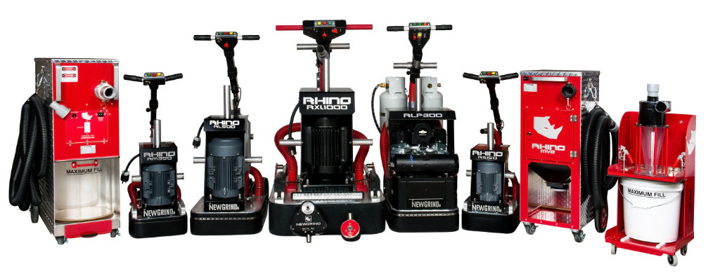

www.newgrind.com

